
Foundations of Internet of Things Lab
20ECP-154

 |  | WORKSHEET
Class: CSE30B |  | Group No.: 8
Group Members Details
S. No. | Name |  | UID
1. | Sandeep Kumar |  | 20BCS4885
2. | Ishank choudhary |  | 20BCS4886
3. | Yogesh Choudhary |  | 20BCS4887
4.

Task:

Hands-on session on Breadboard and Simulation Software.

Requirements:

.

- Fritzing application

- Breadboard

- Arduino UNO

- Led

- Power suplly

- Connecting wires

Circuit Diagram:
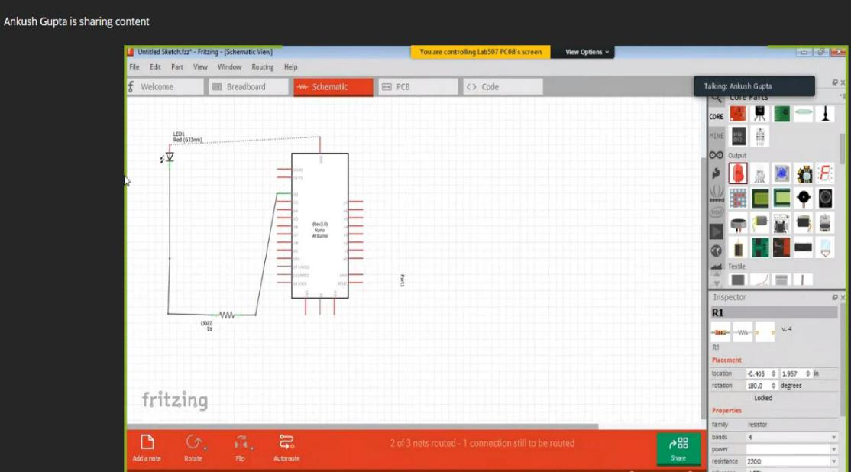
Foundations of Internet of Things Lab
20ECP-154

Code (if any):

/*

Board: DOIT ESP32 DEVKIT V1

*/

#include <WiFi.h>

#define LED 2

#define WIFISSID "Joker" // Your WiFi Name

#define PASSWORD "Joker@tenda" // Your WiFi Password

void setup()

{

- Initializing Serial communication. Serial.begin(9600); Serial.println("Init... T1_Intro");

- initialize digital pin LED as an output. pinMode(LED, OUTPUT);

- Setup up WiFi and Connecting to an active hotspot. Serial.print("\n\nCnonnecting to "); Serial.println(WIFISSID);

WiFi.begin(WIFISSID, PASSWORD); while (WiFi.status() != WL_CONNECTED) { // Waiting for successful connection

delay(500); Serial.print(".");

}

Serial.print("\nRSSI: "); Serial.println(WiFi.RSSI()); Serial.print("WiFi connected. IP address: "); Serial.println(WiFi.localIP());

}

- the loop function runs over and over again forever void loop()

{

digitalWrite(LED, HIGH); // turn the LED on (HIGH is the voltage level)

//Serial.println("HIGH");

delay(500); // wait for a second

digitalWrite(LED, LOW); // turn the LED off by making the voltage LOW //Serial.println("LOW");

delay(500); // wait for a second

Serial.print("\nRSSI: ");

Serial.println(WiFi.RSSI());

Serial.print("WiFi connected. IP address: ");

Serial.println(WiFi.localIP());

}
Foundations of Internet of Things Lab
20ECP-154

Dashboard Snippet (if any):
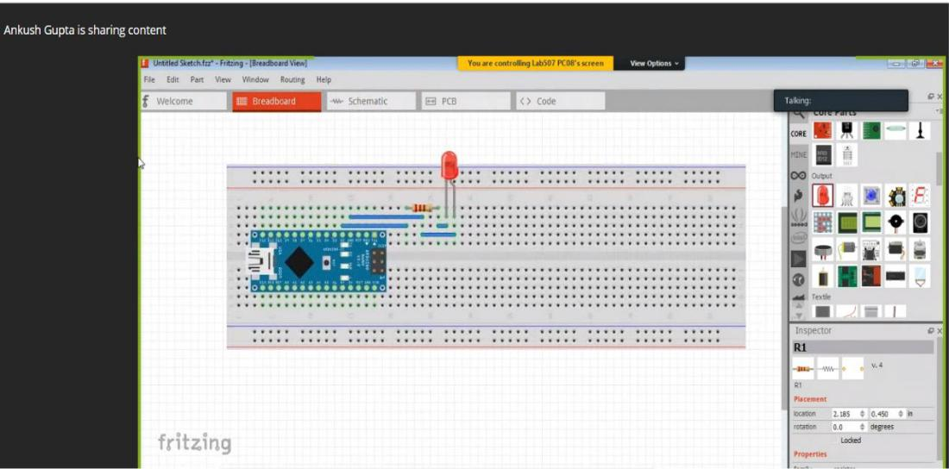

Outcome:
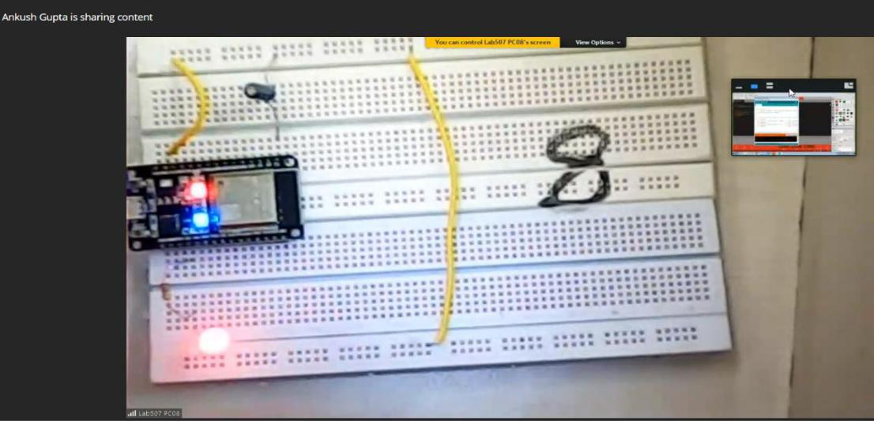

- .Learnt to implement simulation on Fritzing application.

- .Learnt about operating Arduino UNO using simulation software.

- Coding to delay the Led on and off is also been learned during this practical

